37.8: a) The frame in which the source (the searchlight) is stationary is the spacecraft’s frame, so 12.0 ms is the proper time. b) To three figures, Solving Eq. (37.7) for 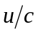in terms of 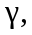
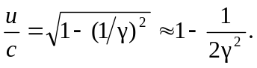
Using

